innovaphone Best Practice
Template: v13/v14 offline update/installation (without access to the store)

www.t-rust.net
© 2023 Tobias Rust IT-Coaching & Consulting
All rights reserved.

Content
Content 2
1 v13/v14 Offline Update/Installation (without access to the Store) 3
1.1 Update Accesses 3
1.2 Store Files Offline 4
1.3 Simple http file server "HFS.exe" 6
1.4 Specifying a new store as an update/installation source 7
Contact 8

v13/v14 Offline Update/Installation (without access to the Store)

Update Accesses

A firmware update on the gateways is still possible via the "classic" version:
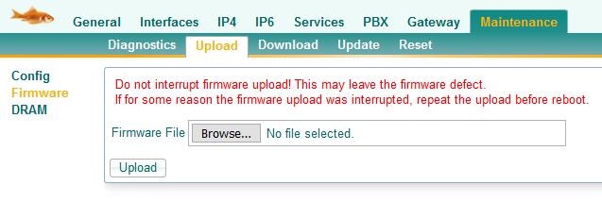

Alternatively, an update from v13 (and later v12) can also be done directly from the innovaphone store:
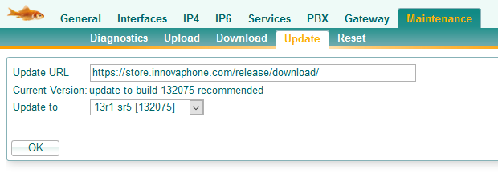

But at the latest when the App Platform is to be installed, access to the files in the store is mandatory.

The installation Wizzard uses the same path to the store:
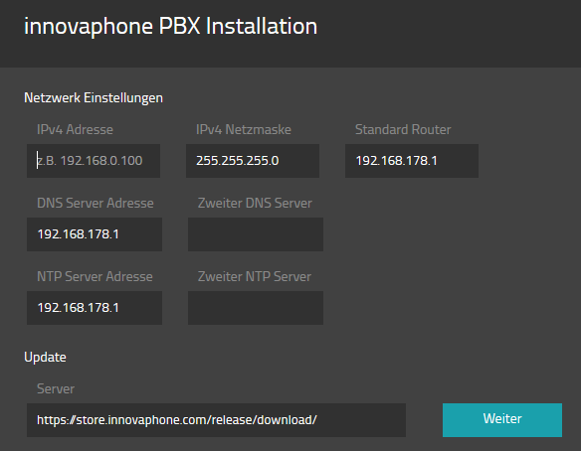

Store Files Offline
Since v13, all innovaphone software, firmware and apps have been available in the innovaphone Store at http://store.innovaphone.com.

The special feature of the store is that not only individual files are downloaded, but so-called installation packages are ALWAYS created with EVERY download, even when downloading individual files.

The installation packages are always built in a special structure, namely the same structure as the store itself.

To provide an offline installation, all required files for this installation MUST be included in a download package.

Example download all apps and firmware for v13sr5:
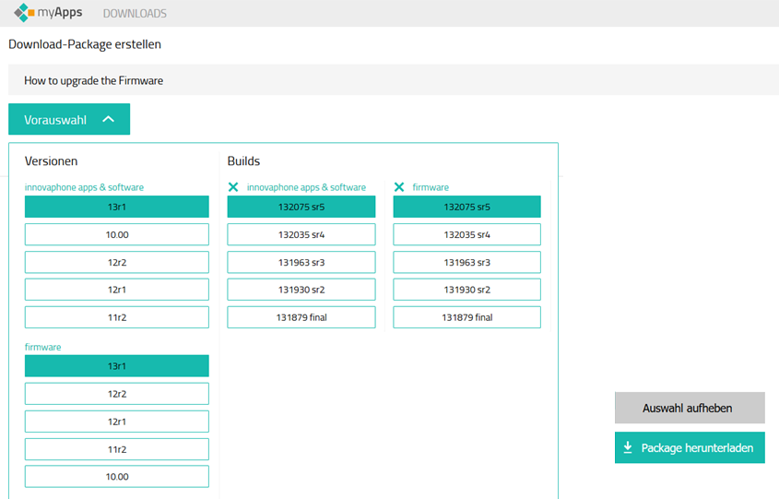

The download package must then be unzipped. The required file structure is present in the unzipped folder and may not be changed.
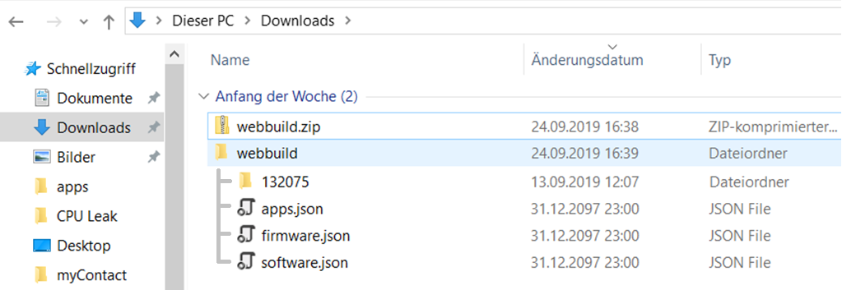

For clarity, however, it is recommended to rename the folder itself, e.g. in the respective version name:
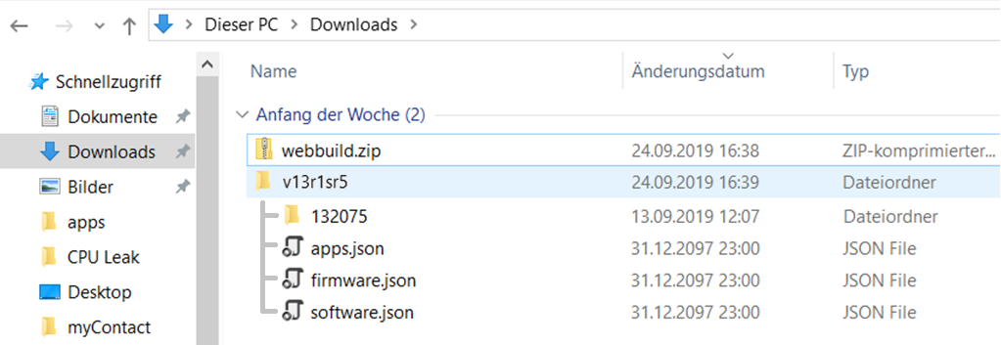

This file structure only needs to be shared in a WebDav directory, this directory path then serves as a store.

Simple http file server "HFS.exe"
- The program "HFS.exe" is a simple http file server that was developed for Windows XP, but also works under Windows 10. No installation is necessary, executing the file "HFS.exe" starts the file server directly.

- Right-click > Add Folder
- Real Folder
- Select the main folder of the store download
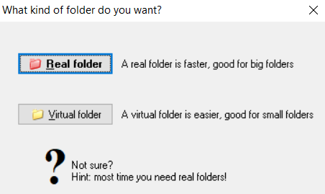
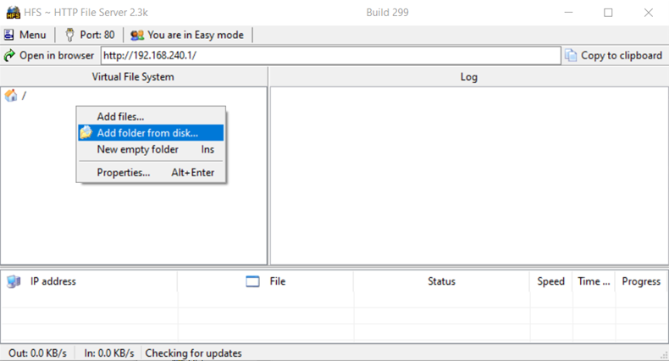
Right Click
- By the way, the HFS server listens on all IP addresses of the local PC, not just the one displayed.
- The http port 80 can be changed if necessary.
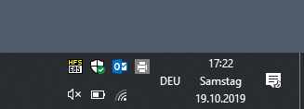
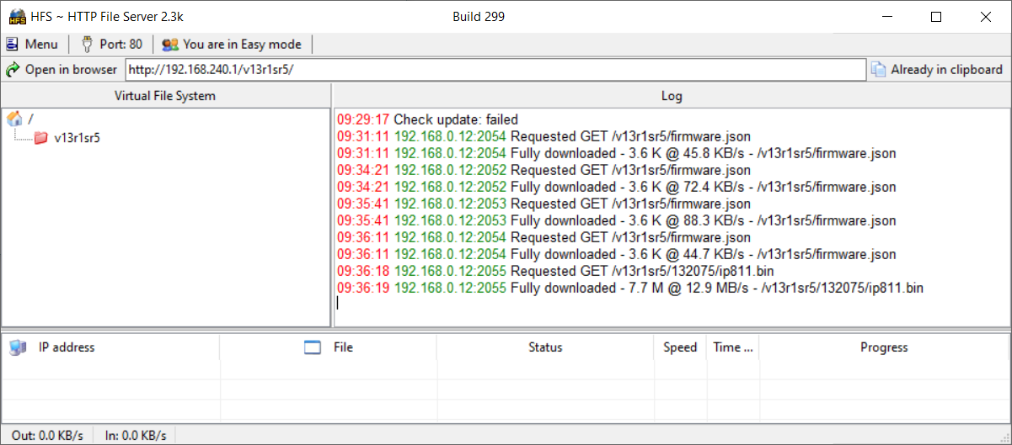
The HFS server disappears as a task ICON >

Specifying a new store as an update/installation source
The URL to the WebDav directory can be used instead of the store:
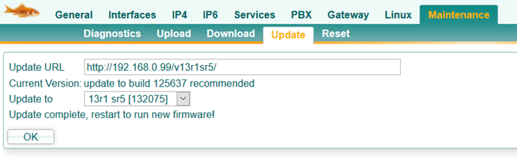

In some places, the respective JSON file has to be specified additionally, but this can be seen in the default settings:
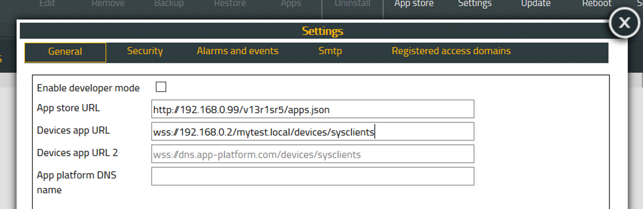

The App Platform itself can also be installed manually on an IPxxx SSD card, here the complete path to the image must be specified.
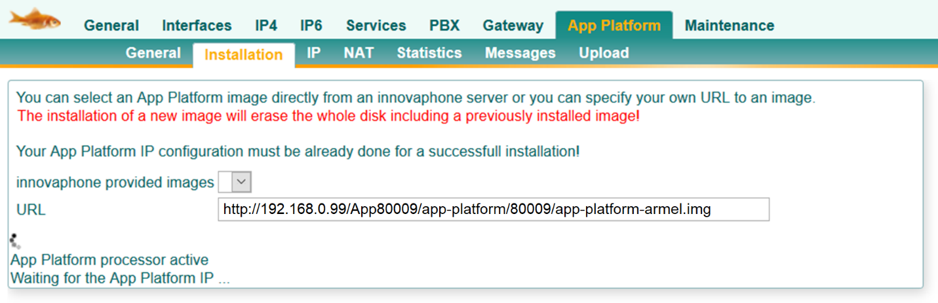

Contact
Do you have any questions about the content, interest in my service or any other concerns?
I look forward to your message.

Tobias Rust
IT Coaching & Consulting
www.t-rust.net
tobias.rust@t-rust.net

