innovaphone Best Practice
Template: Manual installation and update of v12 to v13/v14

www.t-rust.net
© 2023 Tobias Rust IT-Coaching & Consulting
All rights reserved.

Content
Content 2
1 Important Preliminary Remarks 3
2 Manually updating a gateway (with PBX) to v13 without App Platform 4
2.1 Requirements and Adjustments 4
2.2 Update of the gateway 4
2.3 Adjust Necessary Settings 5
2.4 Platform-independent apps are already functional 6
3 Manual update of phones, GWs and DECT without App Platform 7
3.1 Standard Update 7
3.2 Special feature DECT 7
4 Manually install a PBX with App Platform 8
4.1 Standard URLs (Prefixes) 8
4.2 Deploying the platform to an IPxxx via SSD 8
4.3 Deploying the Platform to VMware 10
4.4 Configuring the App Platform 12
4.5 Link between App Platform and PBX 15
4.6 Shortcuts between individual apps and PBX 16
4.7 Basic settings in the PBX 18
5 Setting up basic apps 19
5.1 Devices App 19
5.2 Users App 21
5.3 Reporting App 22
5.4 Contacts App 23
5.5 Events App 24
5.6 Miscellaneous - Templates and Apps 25
Contact 26

Important Preliminary Remarks

The aim of this document is to illustrate the functionality of the innovaphone v13 apps and to show the connections between the PBX and the App Platform.

- The procedure described in this document for manually setting up the App Platform is based on the v13r1sr11 software version.

- The manual setup is not intended to replace the Wizzard, but rather to illustrate the connections between the PBX and the App Platform.

- This document also includes the v13 configuration guide as an Excel sheet. The Excel sheet lists necessary configuration parameters and setup recommendations. References to this Excel sheet are highlighted in color.

Manually updating a gateway (with PBX) to v13 without App Platform

Requirements and Adjustments
The following points should be taken into account during the migration, among others:
- The backward LDAP name resolution (number > name) to external directories (e.g. MetaDir) must now be done centrally in the PBX configuration via the reverse lookup URL.
- For the correct display of phone numbers, the prefixes (National, International, Subscriber, etc.) must now be configured in 3 places.
- The use of templates is now mandatory.

When switching from the Linux AP to the App Platform:
- The name resolution in the reporting app is now also done via the reverse lookup URL in the PBX.
- The reporting app does not yet have all the functionalities as in v12.
- Fax2Mail and Mail2Fax are no longer available.
- Individualized voicemail scripts cannot be provided via the voicemail app, but must be configured manually.

Update of the gateway
The gateway can be easily updated using the classic "Upload" or "Update" method under Maintenance.
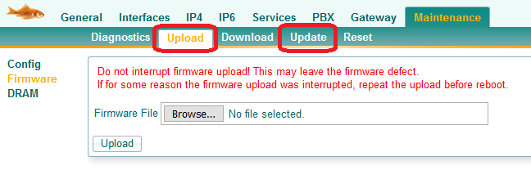
Then "manual configuration" is selected.
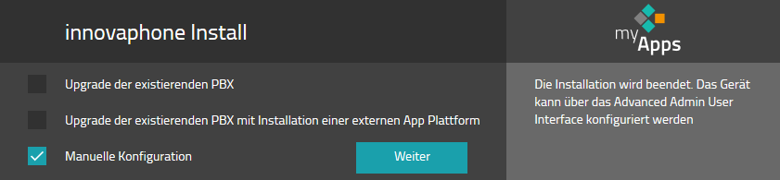

Adjust Necessary Settings
After the update, the following settings need to be adjusted/added.

Services > NTP > Default Time: e.g. "01.01.2020-09:00"
(because without a system time the v13 app environment doesn't work)
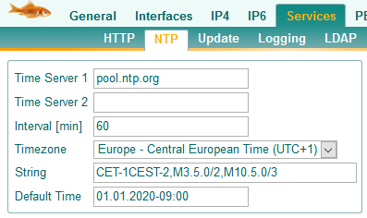

Prefixe for Intl/Ntl/Subscriber/Area/Country in the PBX object
(because otherwise the number display will not work properly)
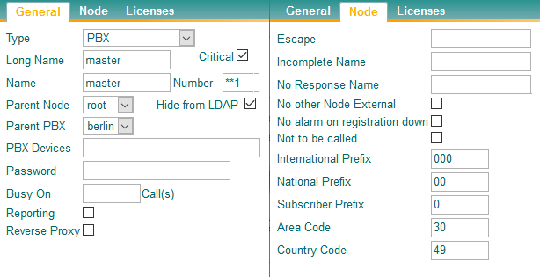

Reverse Lookup URL + Prefix for Intl/Ntl/Subscriber/Area/Country in PBX Settings
(for reverse resolution and correct number display)
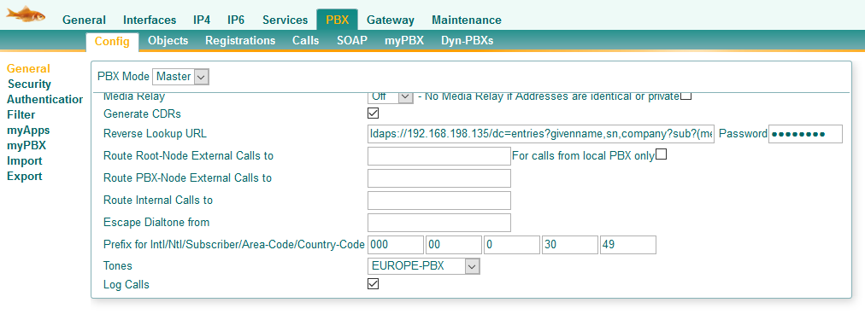

Platform-independent apps are already functional
The standard PBX apps are already available.
http(s)://<IP of PBX>/PBX0/APPCLIENT/appclient.htm
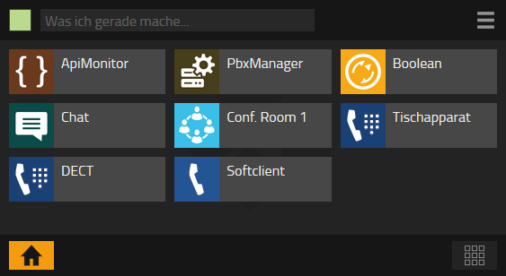

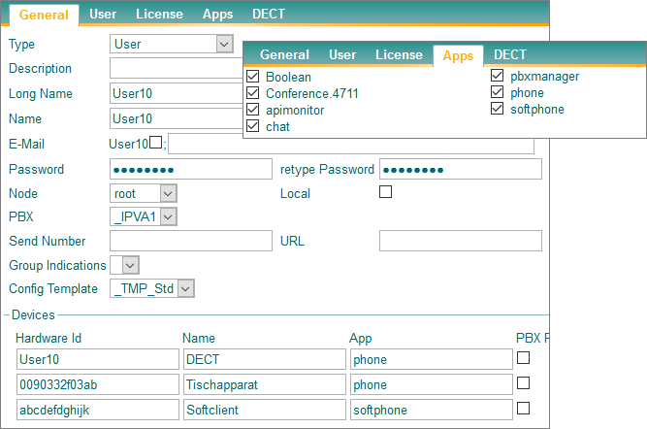

- The call history in the Phone app and Softphone app only works with the App Platform.

- For the LDAP search from the Phone app and Softphone app, an LDAP object must be added.

- The PBX Manager requires the App Platform with the Devices app for many functions.

Manual update of phones, GWs and DECT without App Platform

Standard Update
The devices can be easily updated using the classic "Upload" or "Update" method under Maintenance.

- Of course, update scripts can also be used

Special feature DECT
The LDAP "Reverse Lookup" was previously configured under DECT>Config>Master. However, this was switched off as of v13r1final and now has to be configured via the central PBX setting.
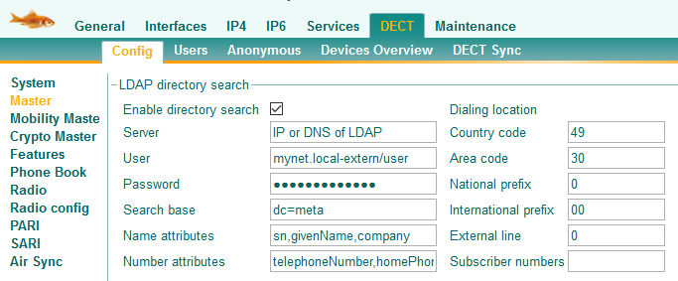
Stopped working since v13r1

- "Forward Search" will be configured unchanged on Phone Book

Manually install a PBX with App Platform

Standard URLs (Prefixes)
The following standard URLs can be used to access the respective instances of the PBX:
The "old" PBX interface: http(s)://<IP of PBX/admin.xml?xsl=admin.xsl
The Install Wizzard: http(s)://<IP of PBX/install.htm
The myApps Client: http(s)://<IP of PBX/PBX0/APPCLIENT/appclient.htm
The myPBX Client: http(s)://<IP of PBX/PBX0/MY/client.htm

Deploying the platform to an IPxxx via SSD
- Turn on App Platform Support
- Configuring IP Parameters
- Select and install the App Platform package

- Don't forget Proxy ARP for IPv4 ETH0 or ETH1!

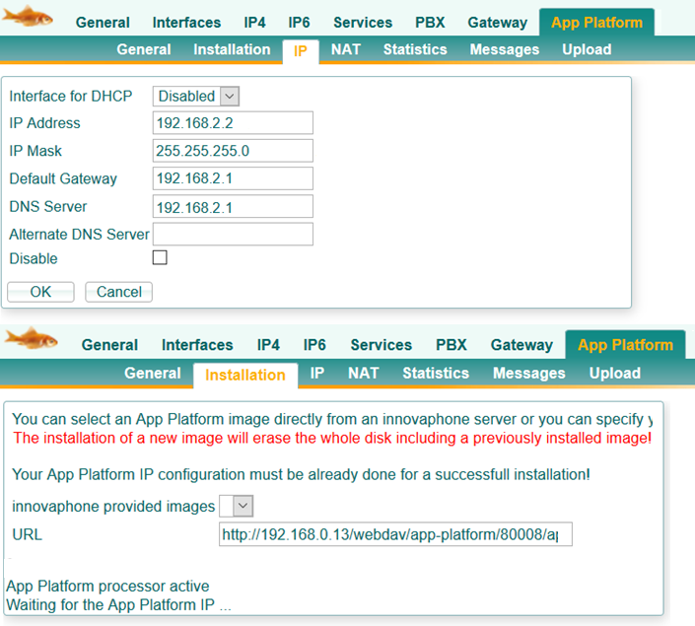

Once installed, the App Platform can be accessed via the browser.

The default passwords are:
manager App (web login): Pwd
SSH-Login with admin: ipapps
Console login with root: iplinux

Deploying the Platform to VMware

Unzip App Platform and open and launch it with VMware or Hyper-V.
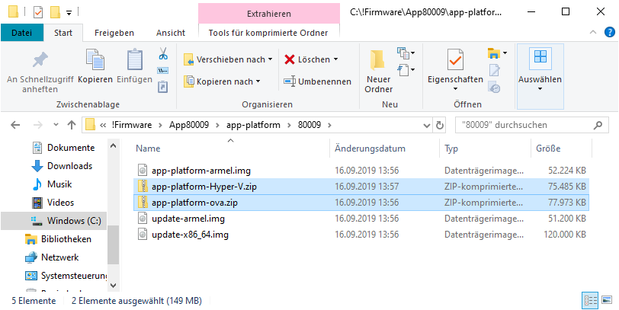
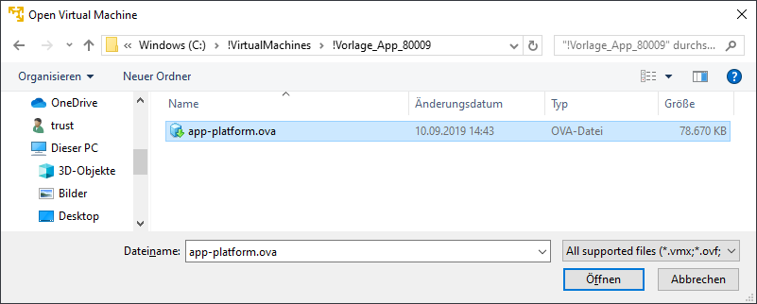

- After starting, an installation script runs and the platform starts again.
- If the start stops at "NTP failed", you have to confirm this in the console with "Enter" to continue the start.
- The App Platform defaults to DHCP, but can also be switched via standard Linux console commands. The IP address is displayed at boot, but can also be queried.

The default passwords are:
manager App (web login): Pwd
SSH-Login with admin: ipapps
Console login with root: iplinux

Overview of useful Linux commands:
Display of IP address:
IP addr

Changing IP addresses:
nano /etc/network/interfaces

Auto eth0
iface eth0 inet dhcp
pre-up /etc/network/nfs_check
wait-delay 15
Hostname $(hostname)
udhcpc_opts -b

Auto eth0
iface eth0 inet static
address 192.0.2.7
netmask 255.255.255.0
gateway 192.0.2.254

To change the name servers:
nano /etc/resolv.conf
nameserver 12.34.56.78
nameserver 12.34.56.79

Network Restart:
sudo /etc/init.d/networking restart
sudo systemctl restart networking
ifdown eth0
ifup eth0

Restart Linux:
poweroff
reboot

Configuring the App Platform

After a manual installation, only the two system apps "Manager" and "Web Server" are available in the App Platform. These must always be updated to the current service release after the basic installation.
- The update of the "Manager" and "Webserver" is done via the "Update All" function in the "Appstore".
- The "Update" function is only intended for updating the Basic Platform (Linux).
- The "Appstore" function now also installs all the apps you want.

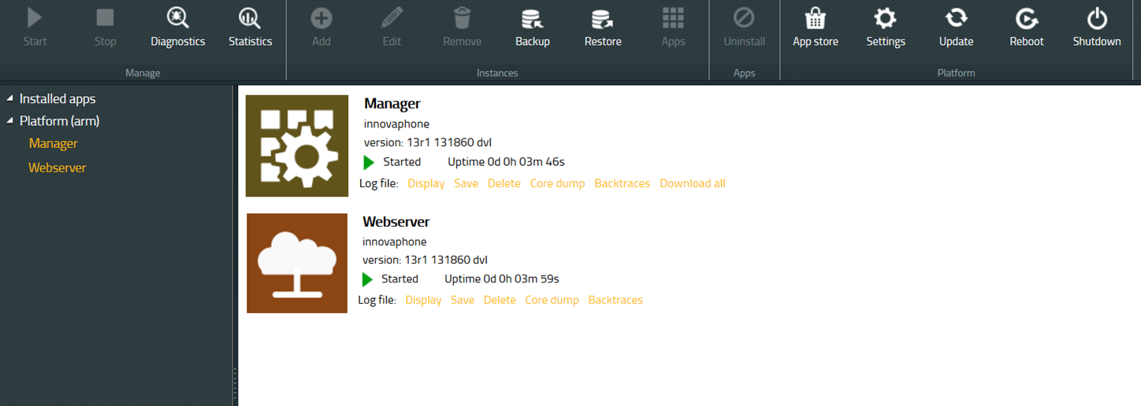

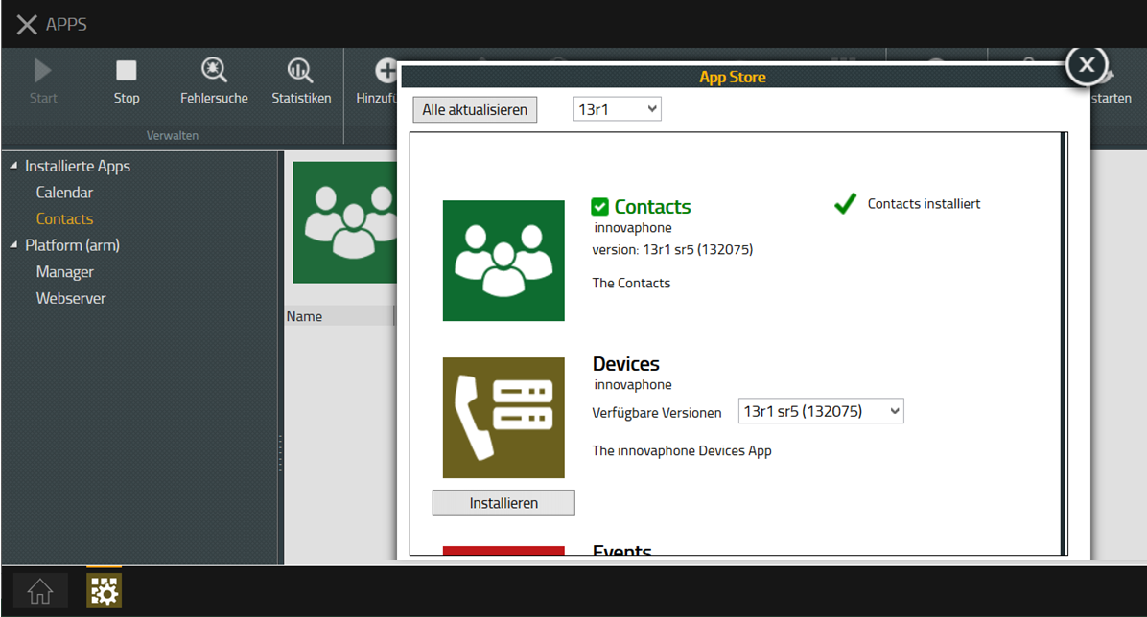

Once the apps have been installed, the instances for each app need to be added. Basically, the following parameters must be specified for each app:
- App Name: The name of the app
- Domain: Must be equal to the "System Name" in the PBX
- Password: Password for the links to the PBX

- The spellings of the apps play a role. The parameters can be found in the configuration guide in the Apps Objects tab .

The configuration is illustrated using the Devices app as an example.
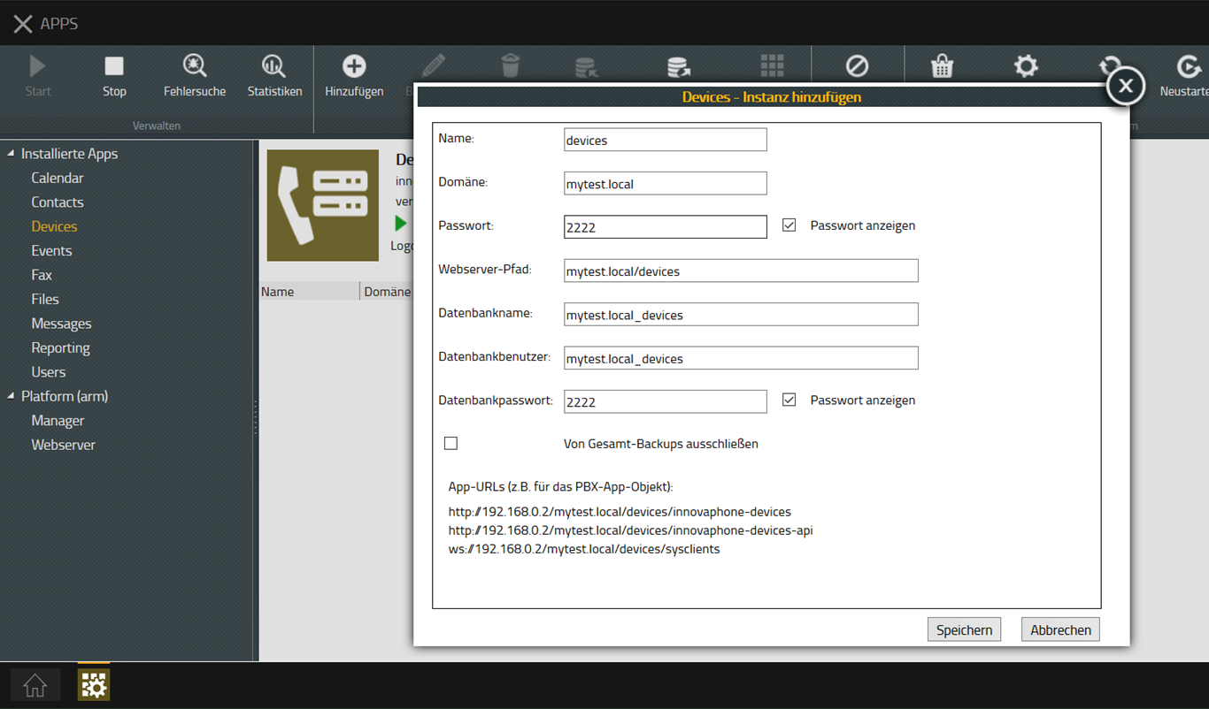

After setting up the instance, it still needs to be started:
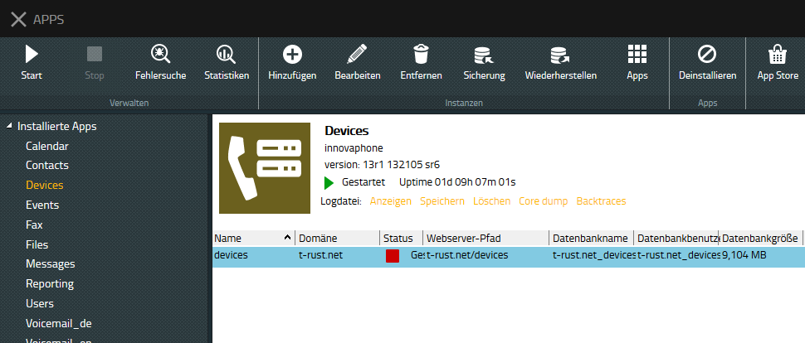

Attention: you can also stop and start the entire app, this is easily confused:
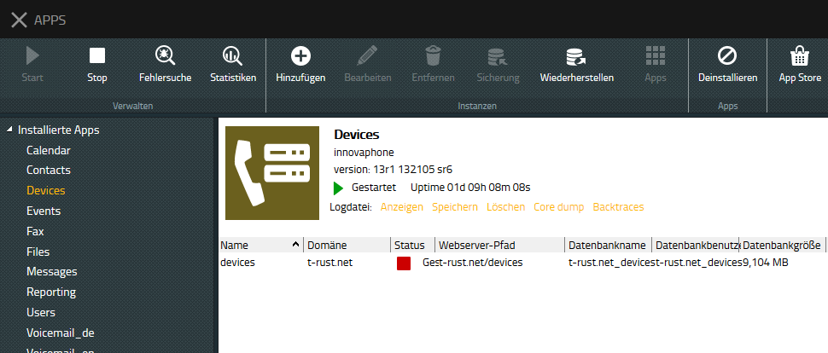

Link between App Platform and PBX
The "main artery" between App Platform and PBX is the AP object in the PBX. This can be added either via the PBXMANAGER, or manually in the PBX.

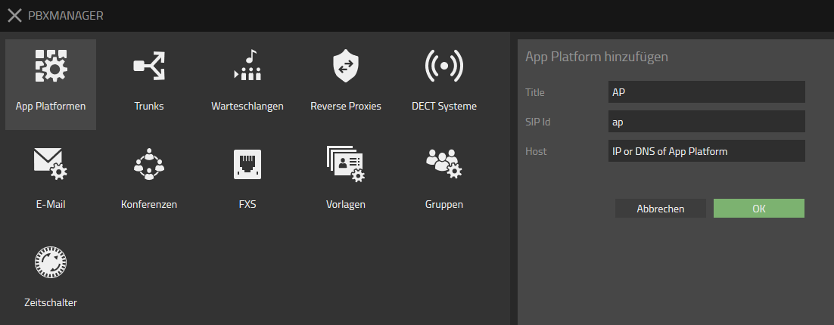
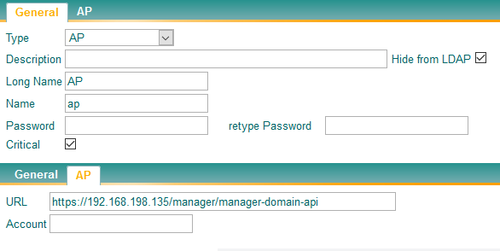

- If the aorta is working, the PBXMANAGER will display all the "colorful" apps that are set up on the App Platform with the same domain name as the PBX.

- The spellings of the apps and users play a role here. The parameters can be found in the configuration guide in the Apps Objects tab .

- NOTE to the password field: This password is the same as the password for the web login to the App Platform. If this password is left blank, the PBX will use the gateway "Admin" password to log in. This makes sense if both passwords are the same.

- If apps are no longer displayed here, the password has usually changed. This must then be corrected manually in the PBX.

Shortcuts between individual apps and PBX
Once the "main artery" between App Platform and PBX is active, the apps that are set up on the App Platform with the same domain name will be displayed.
The apps can then be added either via the PBXMANAGER, or manually in the PBX. As in the example for the Users app.

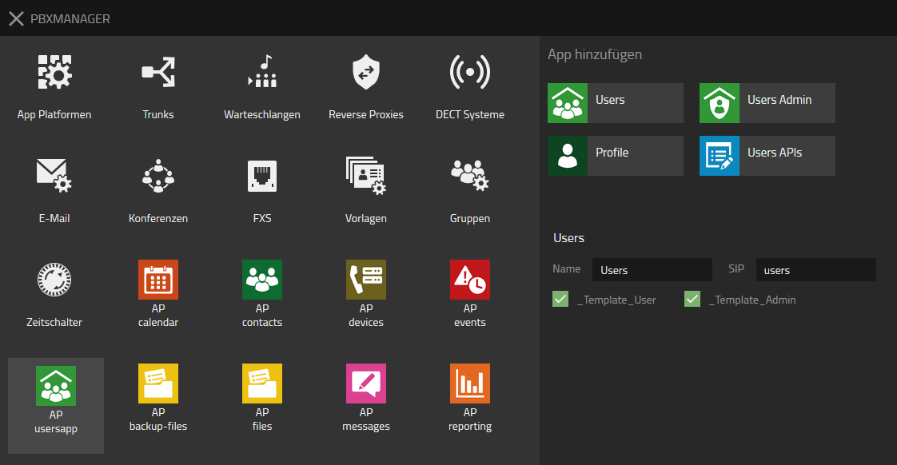
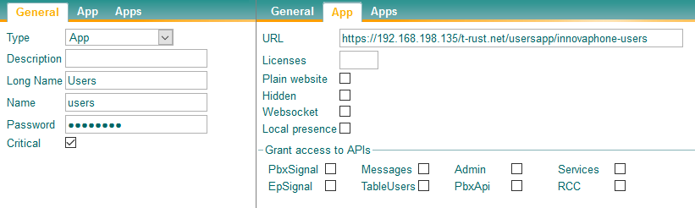

- The spellings of the apps and users also play a role here. The parameters can be found in the configuration guide in the Apps Objects tab . Some apps still need to assign websockets, APIs, or apps.

- NOTE about the password field: This password is the same as the password that was assigned when the instance was created. Attention: Some apps have the peculiarity that they "roll" a new password every time you are called up via the PBXMANAGER. In this case, the password that was manually assigned is no longer valid.

- ATTENTION: Some apps have the peculiarity that every time they are called via the PBXMANAGER, they change the URL in the PBX. E.G. exchange IP address for DNS name or turn http and https around.

For some apps, HTTP client accesses also need to be configured:
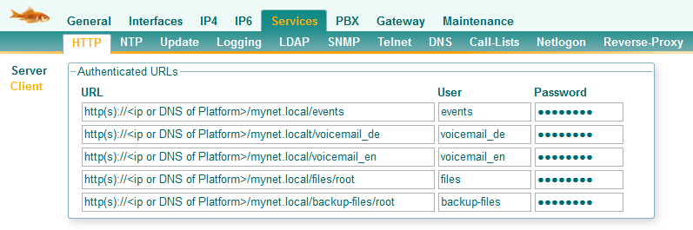
The URLs for events and voicemail no longer need to be configured since v13r1sr11.

- The spellings of the apps and users also play a role here. The parameters can be found in the configuration guide in the Apps URLs tab .

- ATTENTION: Some apps have the peculiarity that they "roll" a new password every time you are called via the PBXMANAGER. In this case, the password that was manually assigned is no longer valid and the new password is unknown. In this case, the password must be assigned manually in the App Platform, in the PBX object, and in the client URLs.

- ATTENTION: Some apps have the peculiarity that every time they are called via the PBXMANAGER, they change the URL in the PBX. E.G. exchange IP address for DNS name or turn http and https around. This must then also be taken into account here.

Basic settings in the PBX

Enter the DNS and IP of the app platform
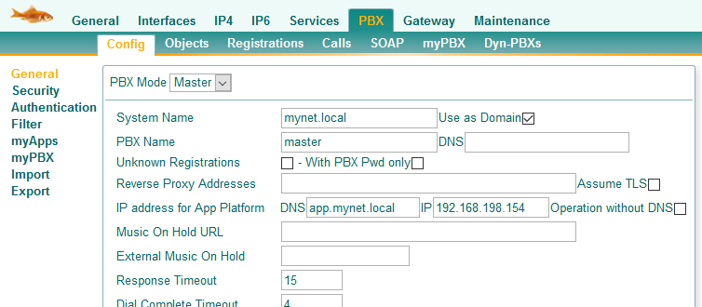

Redirect default PBX URL to the app client
As of v13, the PBX URL is redirected to the app client by default. This can also be configured later via the "http commands":

command: http://<IP of PBX>/!config add HTTP0 /home PBX0/APPCLIENT/appclient.htm
command: http://<IP of PBX>/!config write
command: http://<IP of PBX>/!config activate

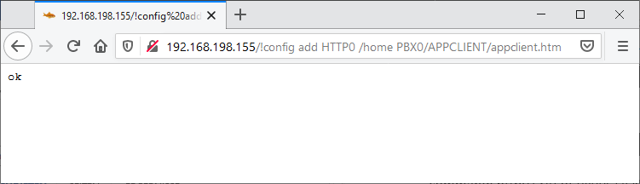

Setting up basic apps

Devices App
The Devices app plays a central role and is an important prerequisite for other apps, e.g. for the Users app, but also for the HW assignments in the PBXMANAGER.
The Devices app should always be set up first.
In the Devices app, the domain must be added first.

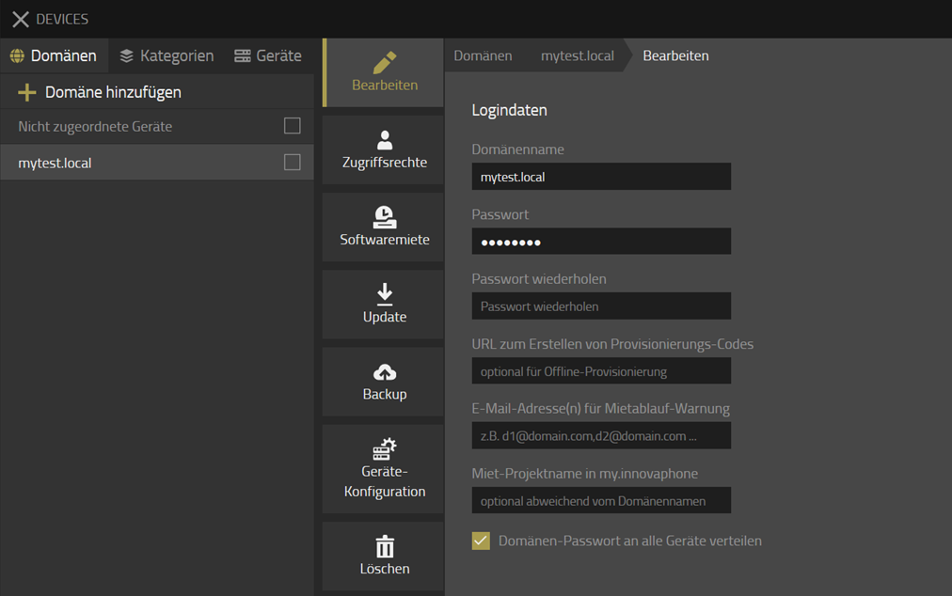

- By ticking the box "Distribute domain password to all devices", all devices will receive the password assigned here. However, the devices must first be connected to this Devices app.
Once the domain has been set up, the categories need to be set up. It is important to have different categories for phones and gateways.
After the categories, the device configurations are then determined. Important are the device configurations for the alarm server, for the media settings (STUN/TURN), and for the telephones.

- A recommendation of all parameters to be set up can be found in the configuration guide in the Apps Settings tab.

After the Devices app is set up, all existing devices must register with the Devices app.
- Enter Devices App URL in App Platform
- Entering Devices App URL in Gateways
- Devices App URL in DECT transmitters
- Devices App URL in Phones

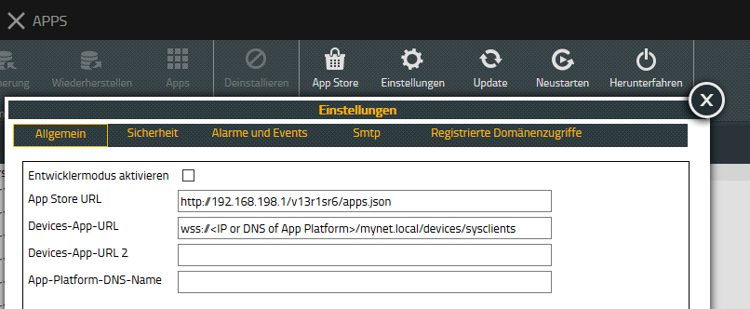
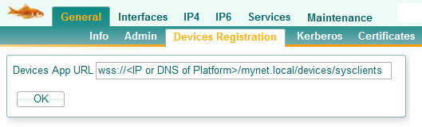

After that, all devices will appear in the overview and can be added to the domain. When adding, a suitable category should be assigned right away, this is highly recommended, at least for telephone.

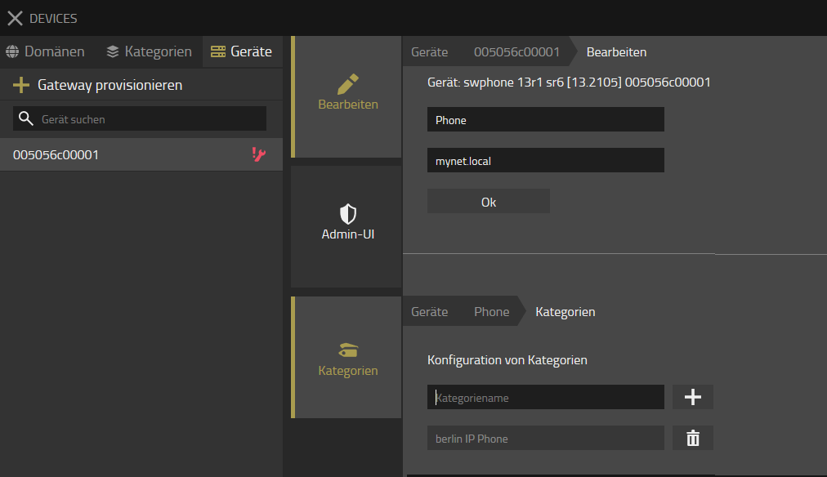

Users App
In the Users App, the PBX name and password must be set. The other settings are optional.
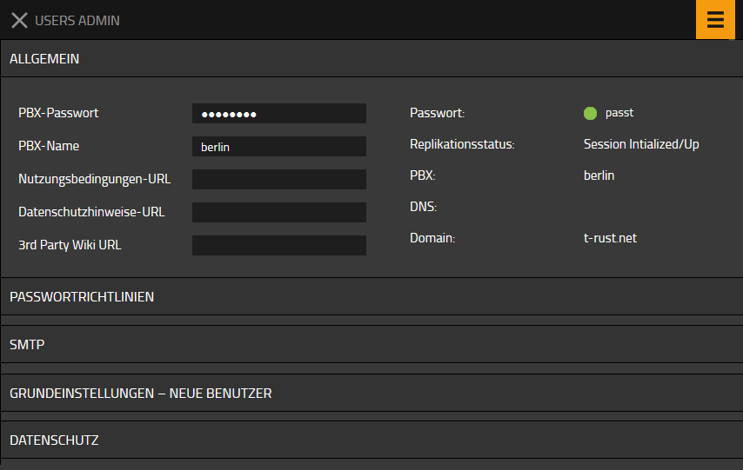

In the myApps settings, the Profile app must be specified. The other settings are optional.
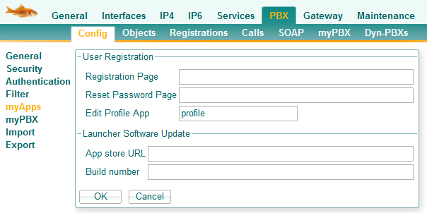
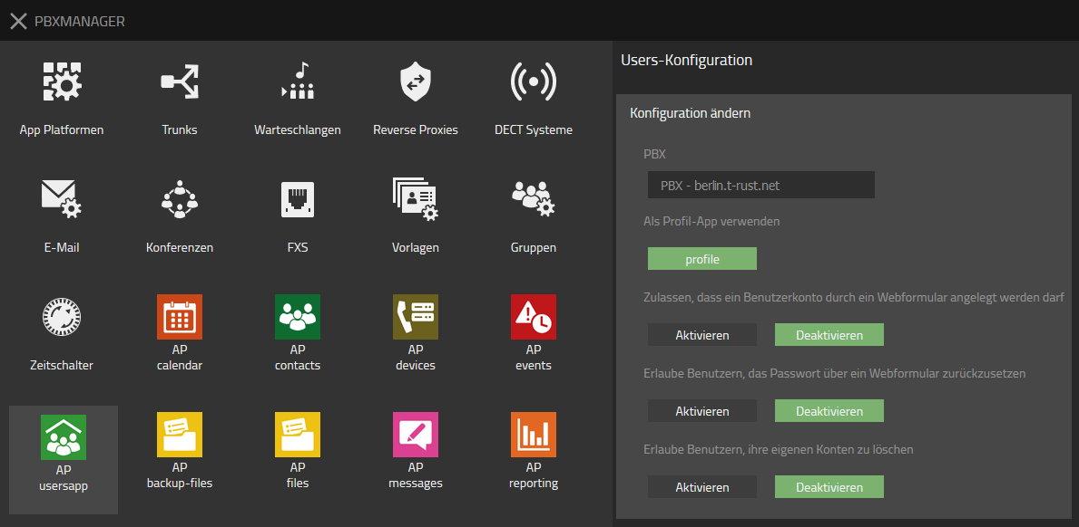

- A recommendation of all parameters to be set up can be found in the configuration guide in the Apps Settings tab.

Reporting App
For the reporting app, the destination for the CDRs still needs to be specified in the PBX gateway.
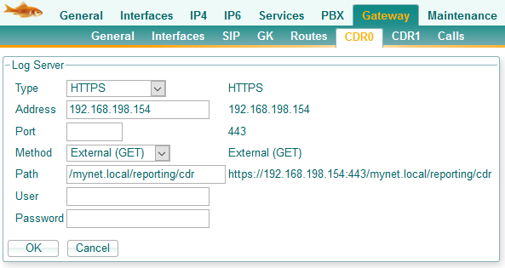
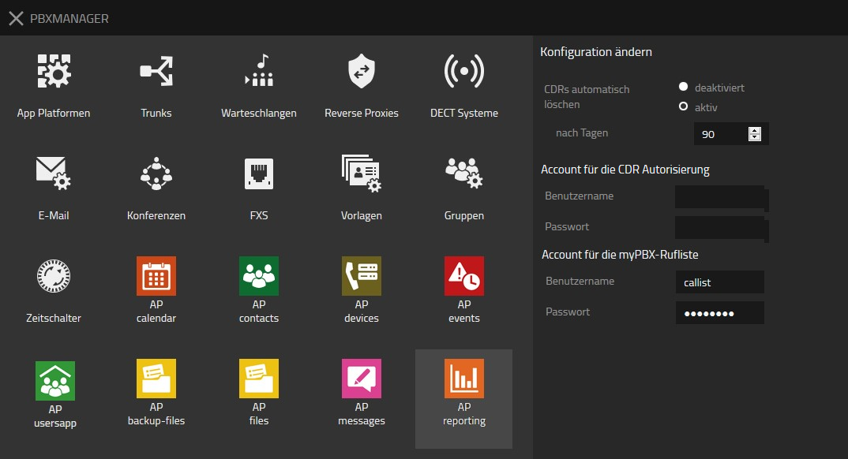
- User and password are optional.
- If necessary, an access for the call list in the myPBX client must be specified if it is to be used in v13.
- The setup of the myPBX Call List can be found in the configuration guide in the Master PBX or Slave PBX tab.

Contacts App
In the Contacts app, the LDAP server must still be activated if end devices are also to access the Contacts entries.
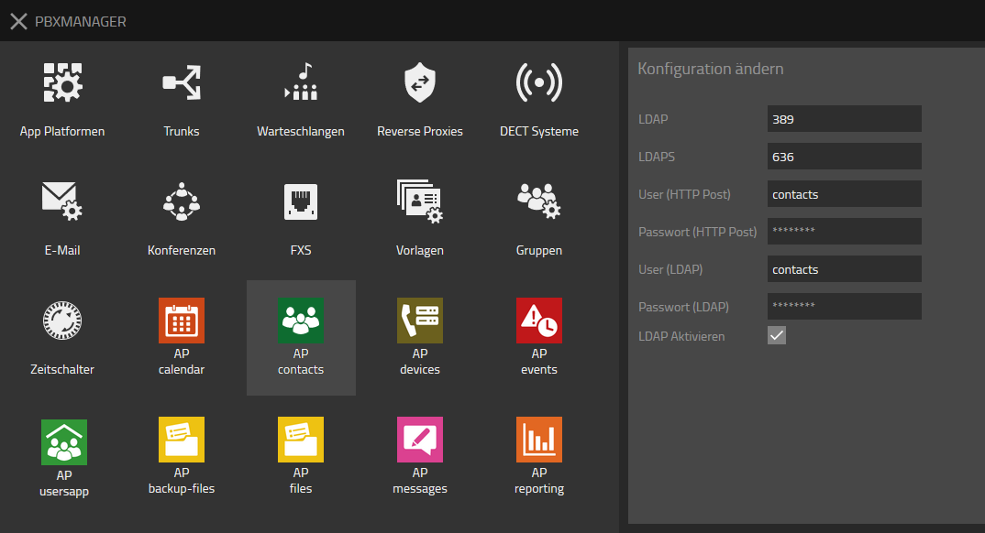

Attention: The domain name given here is automatically preceded by the domain name, but this is not displayed anywhere, but must be taken into account in the end devices!
Example: The username "contacts" is actually "mynet.local\contacts"

- The setup of LDAP entries for the Contacts app can be found in the configuration guide in the Master PBX or Slave PBX tab.

Events App
In the Events app, since v13r1sr7, the http credentials have to be configured. These credentials are either also entered in the gateways or distributed via the device configuration in the Devices app.

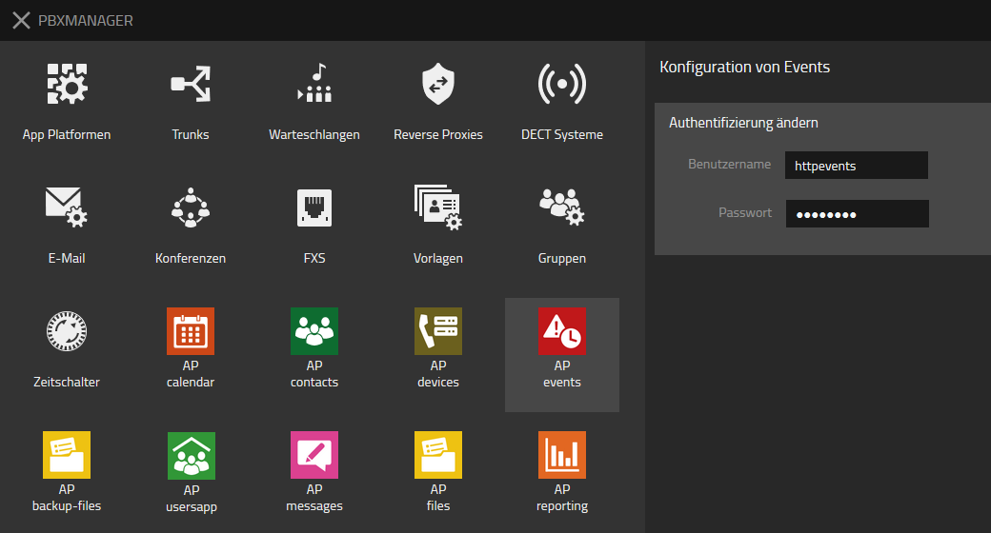

Miscellaneous - Templates and Apps
Since v13, templates are mandatory as soon as the App Platform is used. The user app only works with templates and all apps are distributed via templates.

The assignment of the apps to the templates can be done directly in the PBXMANAGER for the apps, but this is not yet implemented consistently for all apps.
The best way is to assign the apps in the templates.
However, you have to make sure that you have to assign the corresponding "API app" in addition to the desired app. For example, the Users app will only work correctly if the Users API app is also assigned.

- As a rule of thumb, you can remember that you always have to assign the API app to a user for a "normal" app, if it is available.

Contact
Do you have any questions about the content, interest in my service or any other concerns?
I look forward to your message.

Tobias Rust
IT Coaching & Consulting
www.t-rust.net
tobias.rust@t-rust.net

