innovaphone Best Practice
Template: External LDAP directory on v13/v14 PBX and App Platform

www.t-rust.net
© 2023 Tobias Rust IT-Coaching & Consulting
All rights reserved.

Content
Content 2
1 v13 Characteristics for an external LDAP 3
1.1 Central PBX Setting for Reverse Lookup 3
1.2 Specifying the prefixes for correct display and resolution 4
1.3 LDAP search for phones and myPBX client 5
1.4 LDAP lookup for myApps client 6
1.5 LDAP search for DECT 7
2 LDAP Parameters for Contacts App 8
2.1 Introduction/Note 8
2.2 Enable LDAP Server in Contacts App 8
2.3 Reverse Lookup URL for Contacts App 8
2.4 User Settings for Contacts App (Forward Search) 9
2.5 DECT Settings for Contacts App (Forward Search) 10
Contact 11

v13 Characteristics for an external LDAP

Central PBX Setting for Reverse Lookup
The reverse lookup settings for the reverse resolution of the phone numbers are now made centrally in the PBX configuration.
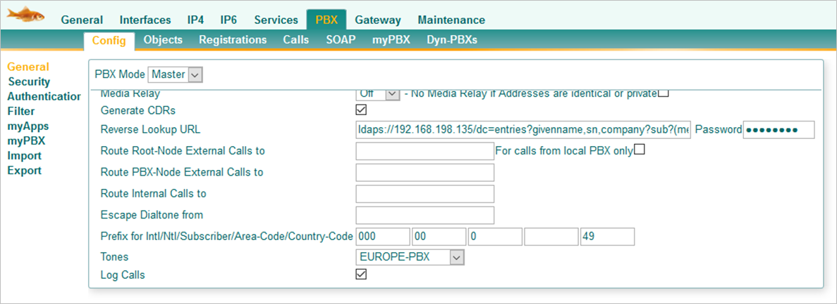
Example:
ldap://metadir.domain.tld:712/dc=meta?givenname,sn,company?sub? (|(telephoneNumber=+%n) (mobile=+%n) (homePhone=+%n))? bindname=username
Construction:
[ldap://metadir.domain.tld:712]/[dc=meta]?[givenname,sn,company]?sub?(|[(telephoneNumber=+%n)(mobile=+%n)(homePhone=+%n)])?bindname=[username]
1. Specifying the server
ldap://metadir.domain.tld:712 or:389 for standard LDAP
ldaps://metadir.domain.tld:714 or:636 for standard LDAPS

2. Specification of the search base
e.g. dc=meta

3. Specifying the Name Fields
givenname,sn,company Name attributes comma separated and without spaces

4. Specifying the number fields for the search
(telephoneNumber=+%n) (mobile=+%n) (homePhone=+%n)
Number field is structured: Number attribute followed by "=+%n" (%n is replaced by phone number). For this purpose, the LDAP must be maintained in an international format.

5. Username
Specifying the username

Hint:
The following variables can be used in the search box:
- %n - cgpn
- %u - h323 name of the current object
Thus, dc=%u should also work as a user-specific search base. BUT: Then ALL users must have a search base.

Specifying the prefixes for correct display and resolution
Since v13 there are now 3 places where the prefixes must be specified so that the display and resolution of the phone number is correct.
1. Directly in the PBX below the reverse lookup URL
See previous chapter: Prefix for Intl/Ntl/Subscriber/Area-Code/Country-Code
- In this case, the information is always provided including the official code
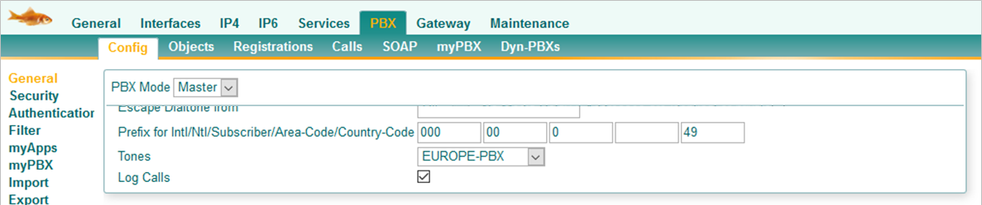
2. In the PBX object
The entries in the PBX object are only necessary if the PBX object is used as a node.
- Here, too, the information is always provided including the official code
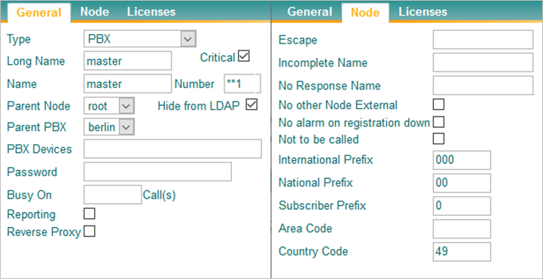
3. In the directory settings of the user or in the template
- The information must always be provided here, even if no directory is entered here!!
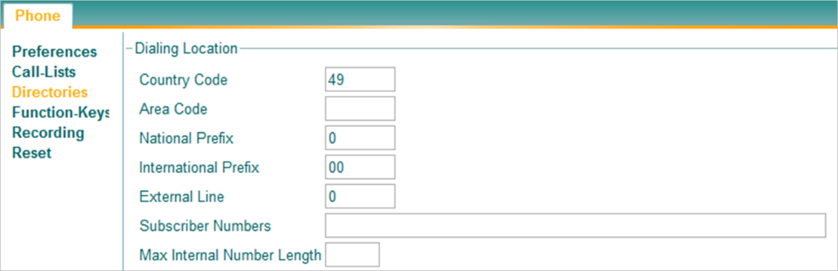

LDAP search for phones and myPBX client
The LDAP search for the phones and the myPBX client is carried out directly at the user's site or distributed via templates.
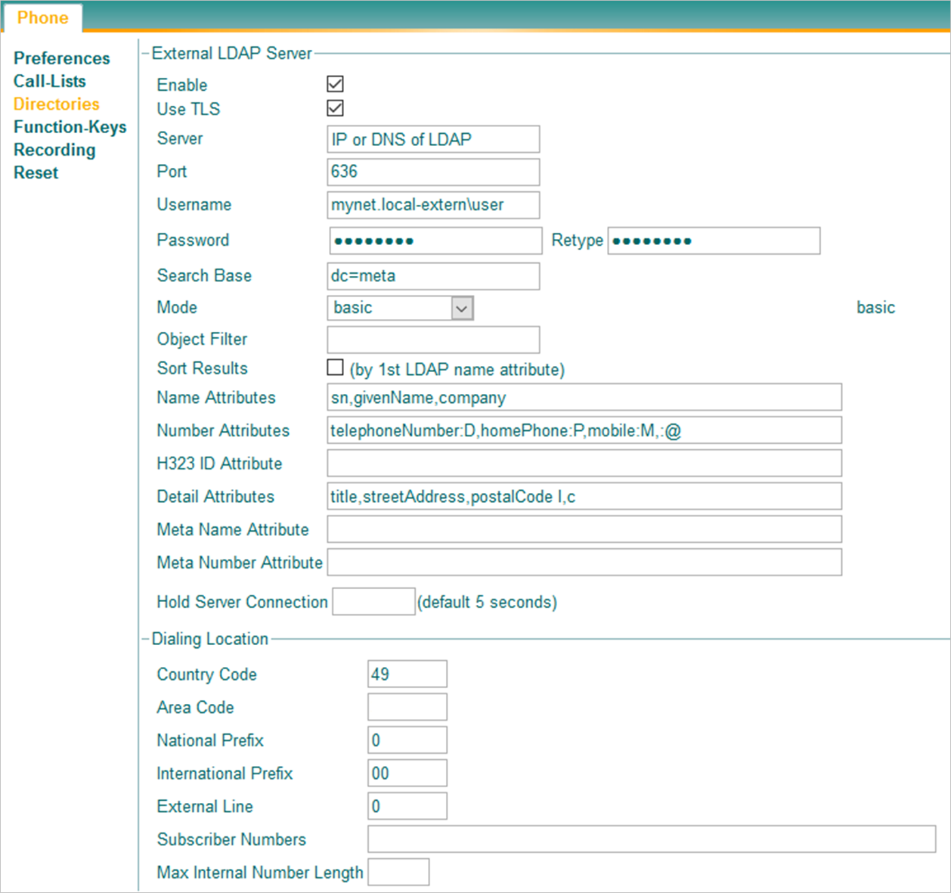

The reverse lookup at the user or in the template has to be disabled since v13:
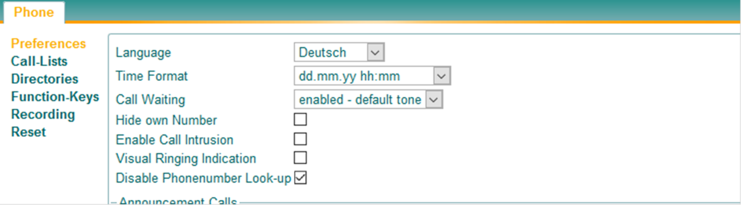

LDAP lookup for myApps client
For the LDAP search from the myApps client, an LDAP object must be created. This LDAP object is then assigned to the respective users under the apps. Every user who has been assigned this LDAP object will automatically search in this directory from the Phone app.

- This LDAP search only works forwards, the reverse search must be configured via the central PBX setting.

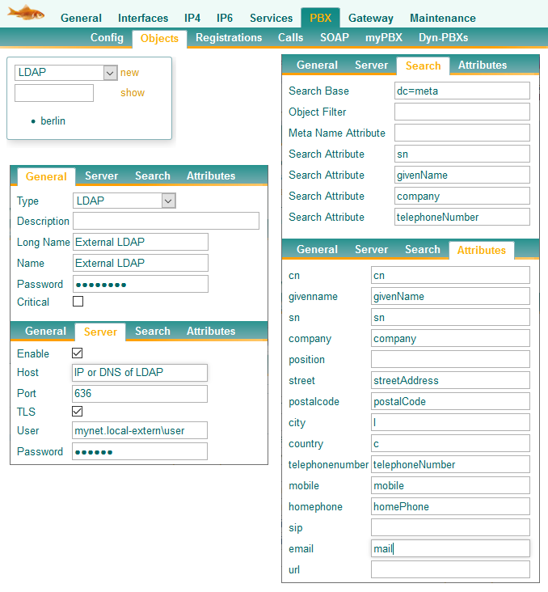

LDAP search for DECT
The "normal" forward search will be configured as before under DECT>Config>Phone Book.
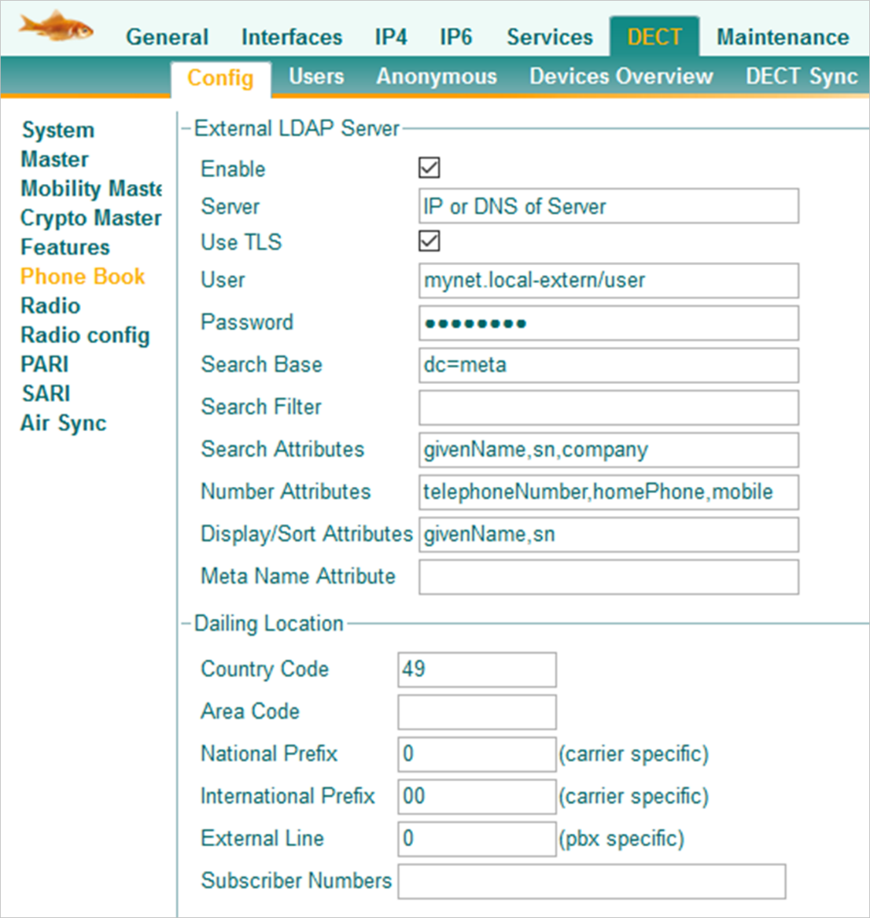

The "reverse lookup" was previously configured under DECT>Config>Master. However, this was switched off as of v13r1final and now has to be configured via the central PBX setting. (Reverse Lookup)
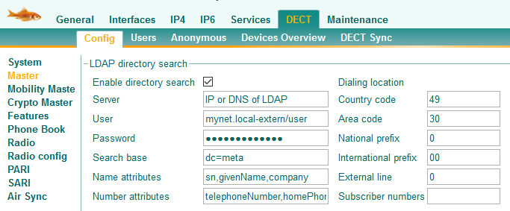
Stopped working since v13r1

LDAP Parameters for Contacts App

Introduction/Note
As soon as contacts are available in the Contacts app and a user has been assigned the Contacts app, the contacts are also displayed in the myApps client.
However, for the time being only in the myApps client and only for the "forward search".
In order to make the contacts of the Contacts app available for phones (IPxxx or DECT), further configuration steps are necessary. The reverse lookup URL must also be adjusted.

Enable LDAP Server in Contacts App
In the Contacts app, the LDAP server must first be activated.
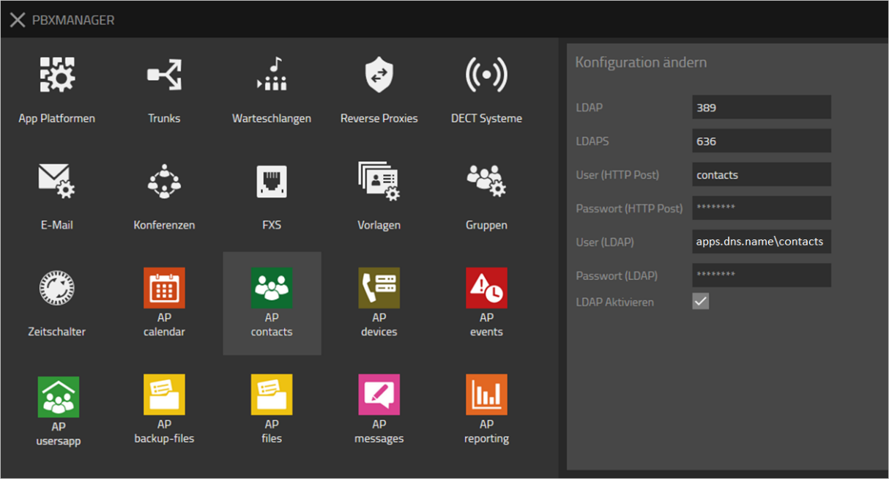
- Note: The username given here is in the format "<DNS_Name_der_App_Platform>\contacts" since version v13r3. This format is used by the reverse proxy to forward LDAP requests from outside.

Reverse Lookup URL for Contacts App
By default, the reverse lookup URL for the Contacts app is structured as follows:
ldaps://<IP_or_DNS_App_Platform>/dc=entries?givenname,sn,company?sub? (metaSearchNumber=+%n)?bindname=apps.dns.name\contacts

User Settings for Contacts App (Forward Search)
The following parameters must be set for the directory settings in the users/templates:
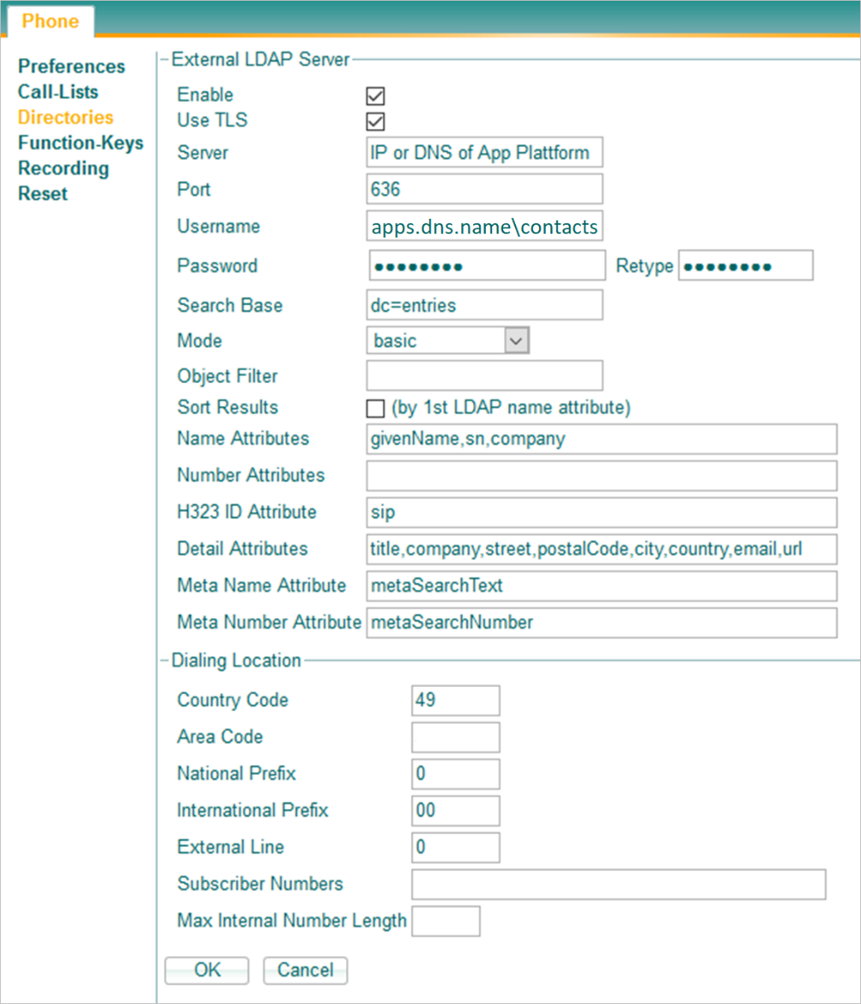

DECT Settings for Contacts App (Forward Search)
The following parameters must be set for the directory settings in the DECT Master and DECT standby:
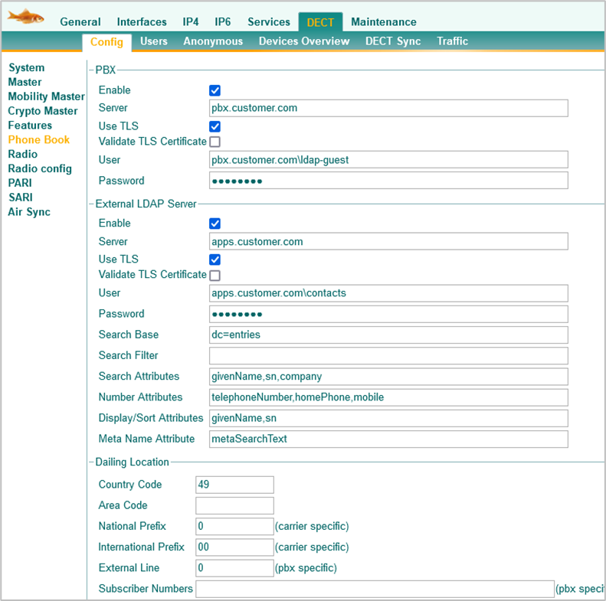

Contact
Do you have any questions about the content, interest in my service or any other concerns?
I look forward to your message.

Tobias Rust
IT Coaching & Consulting
www.t-rust.net
tobias.rust@t-rust.net

